
Prepared By: Javra Software Nepal
Date: 18 March 2016
Laser UI User Guide
LJ-V7000 Series

New User Interface for the laser Device Data Integration system
- Introduction
After discussion with Mr. Frank and the Euro-mit team, we concluded to made new user Interface for laser device data integration system. We believe it will be more users friendly and understandable than previous UI.

- Preview of New User Interface
- Task manger Measure slit tab.
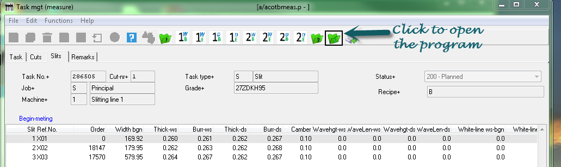

- Laser device data integration system

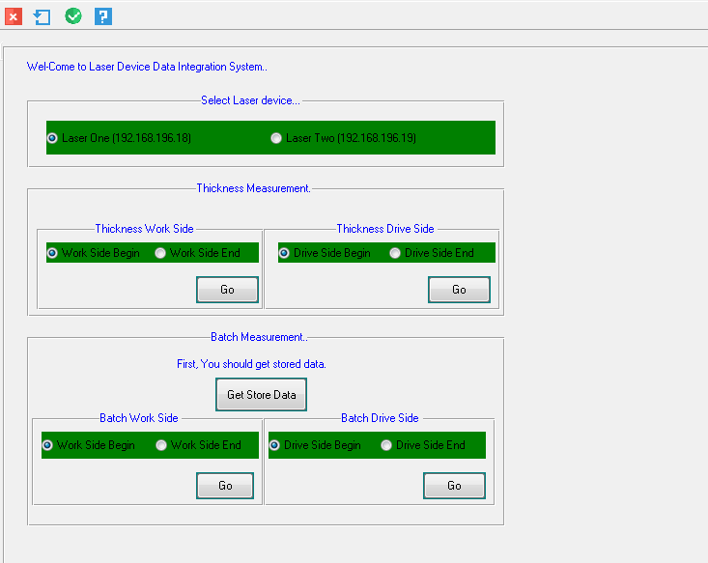

- Thickness
For thickness, first of all we should select the ip address from which we will measure data and select steel site (work side or drive side) then click go button, it will give you thickness of steel.

In pop up form you can see Yes and No button which is for confirmation of data and rejection of data respectively.
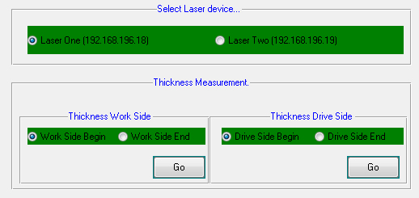

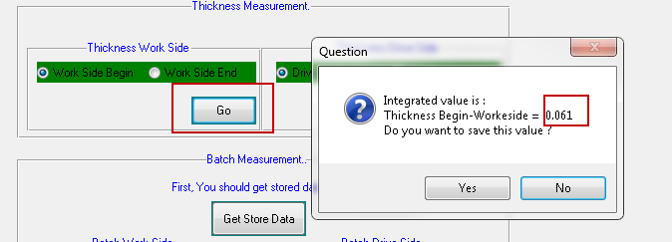

Same process will repeat for both work side and drive side.

2 . Batch Measurement

For batch measurement first of all we should select ip address and then store the data to the specified location by pressing Get Store Data.
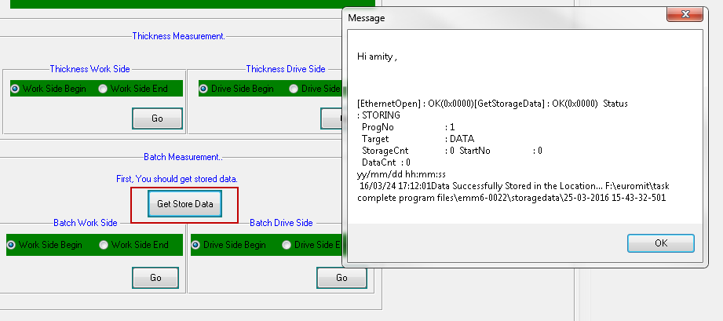
(Recently there is not stored data so that storage count and data count is 0).

After stored the data we should select steel site (work side or drive side) by clicking green coloured radio button, after that user can click on go button to store the data to the EMS system.

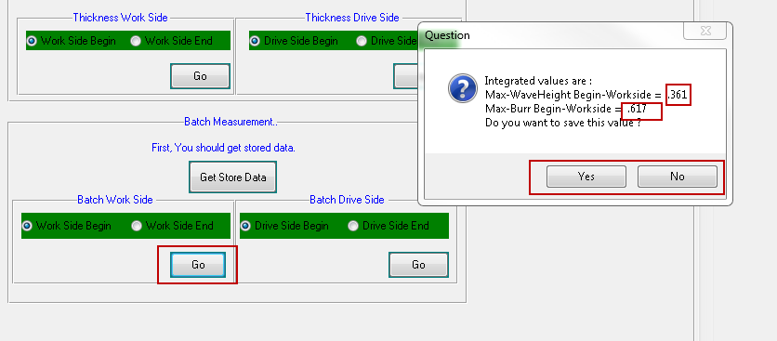

In PopUp form you can find yes and no options, this for the confirmation and rejection of the data respectively.
3 . Final Output
All the measured output will stored in the task management program at specific location.
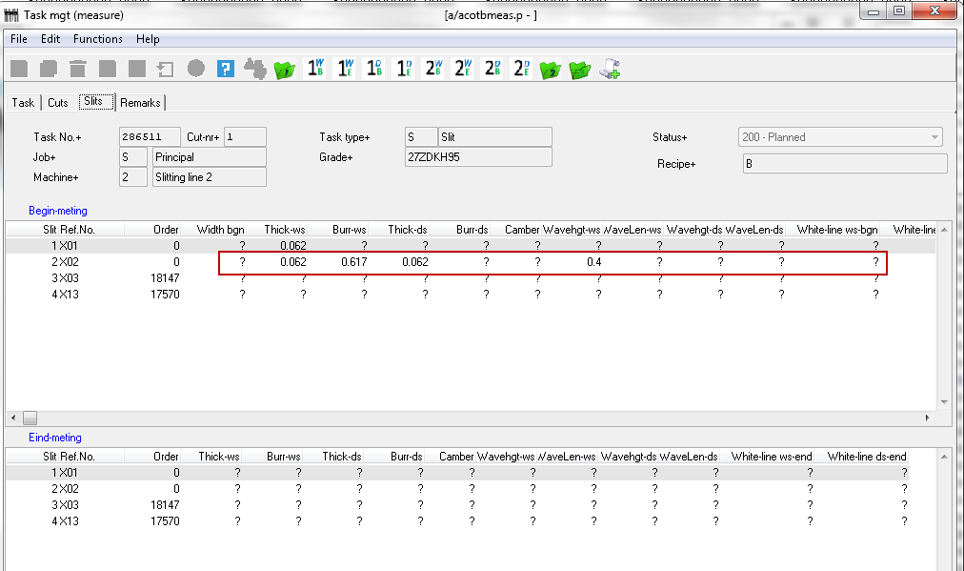

- Future Expansion :
- Maximum value will be taken from records, only those values which are come before the negative value.

